CREATE TABLE

KIRUTHIGAA.K
513423104010

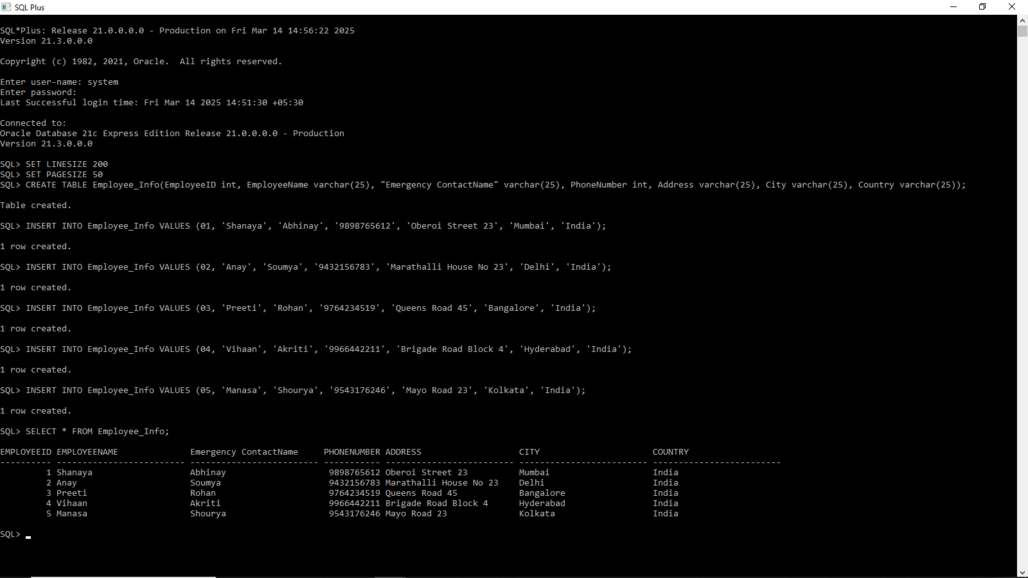

The CREATE TABLE command is used to make a new table in a database. It defines the table name, column names, and data types for storing information. You can also add rules like PRIMARY KEY to make sure each row is unique.

TRUNCATING TABLE

KIRUTHIGAA.K
513423104010

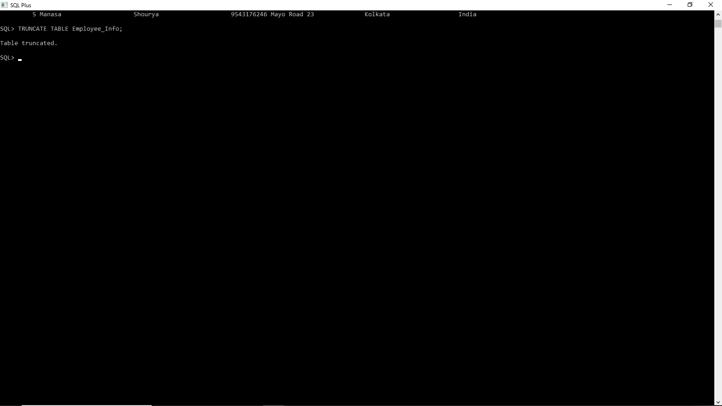

The TRUNCATE TABLE command removes all data from a table but keeps the table structure. It works faster than DELETE because it does not log each row deletion. Once executed, the deleted data cannot be recovered.

ALTER TABLE

KIRUTHIGAA.K
513423104010

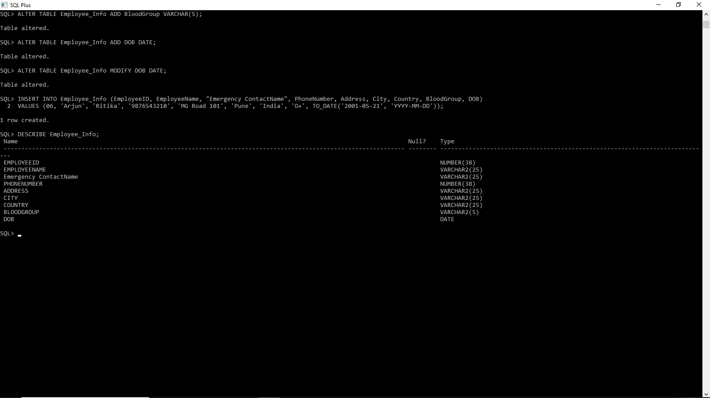

The ALTER TABLE command is used to modify an existing table by adding, deleting, or changing columns. It helps update the table structure without losing existing data. You can also use it to add constraints like NOT NULL or UNIQUE.

CONSTRAINTS

KIRUTHIGAA.K
513423104010

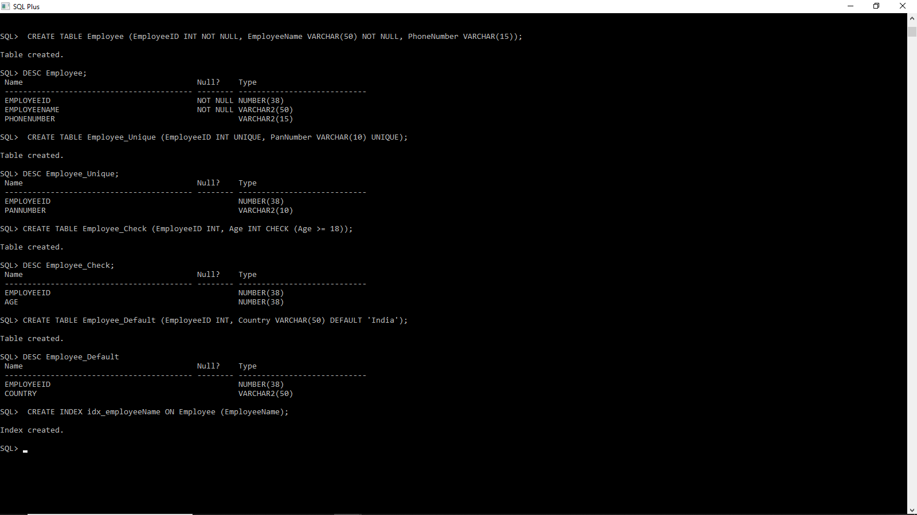

Constraints in SQL
- NOT NULL – Ensures a column cannot have empty (NULL) values.
- UNIQUE – Ensures all values in a column are different.
- CHECK – Sets a condition that data must meet before being inserted.
- DEFAULT – Assigns a default value if no value is provided.
- INDEX – Speeds up searches by creating an index on a column.

SELECT STATEMENTS

KIRUTHIGAA.K
513423104010

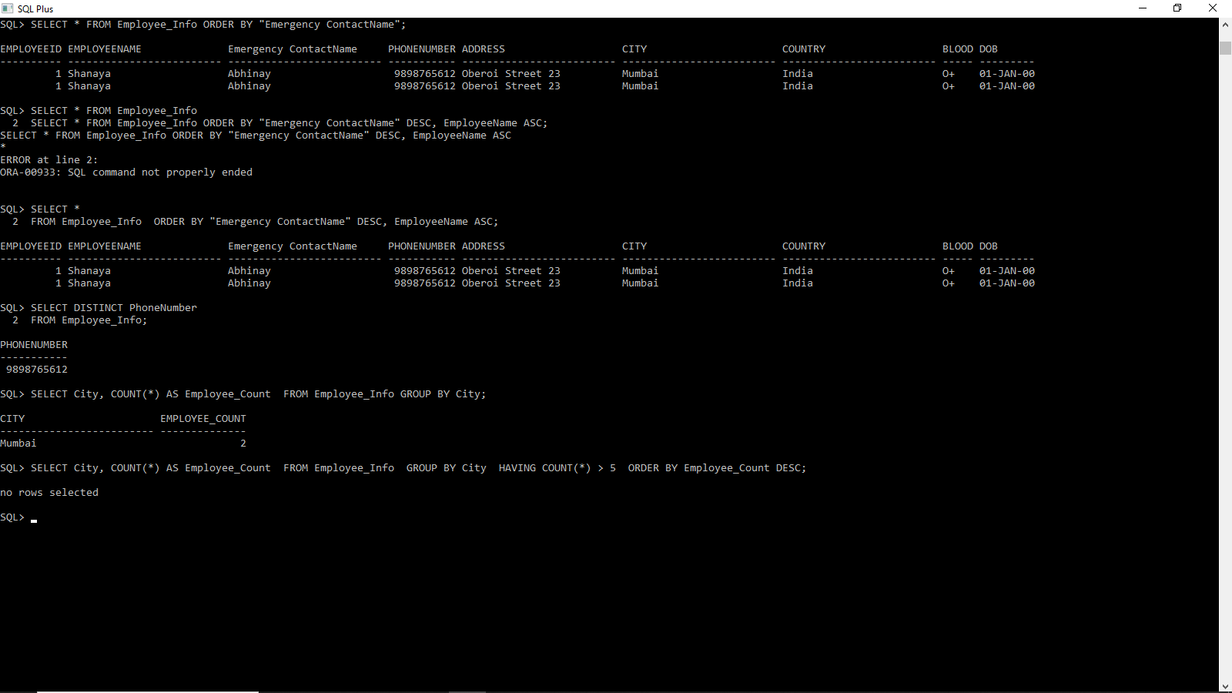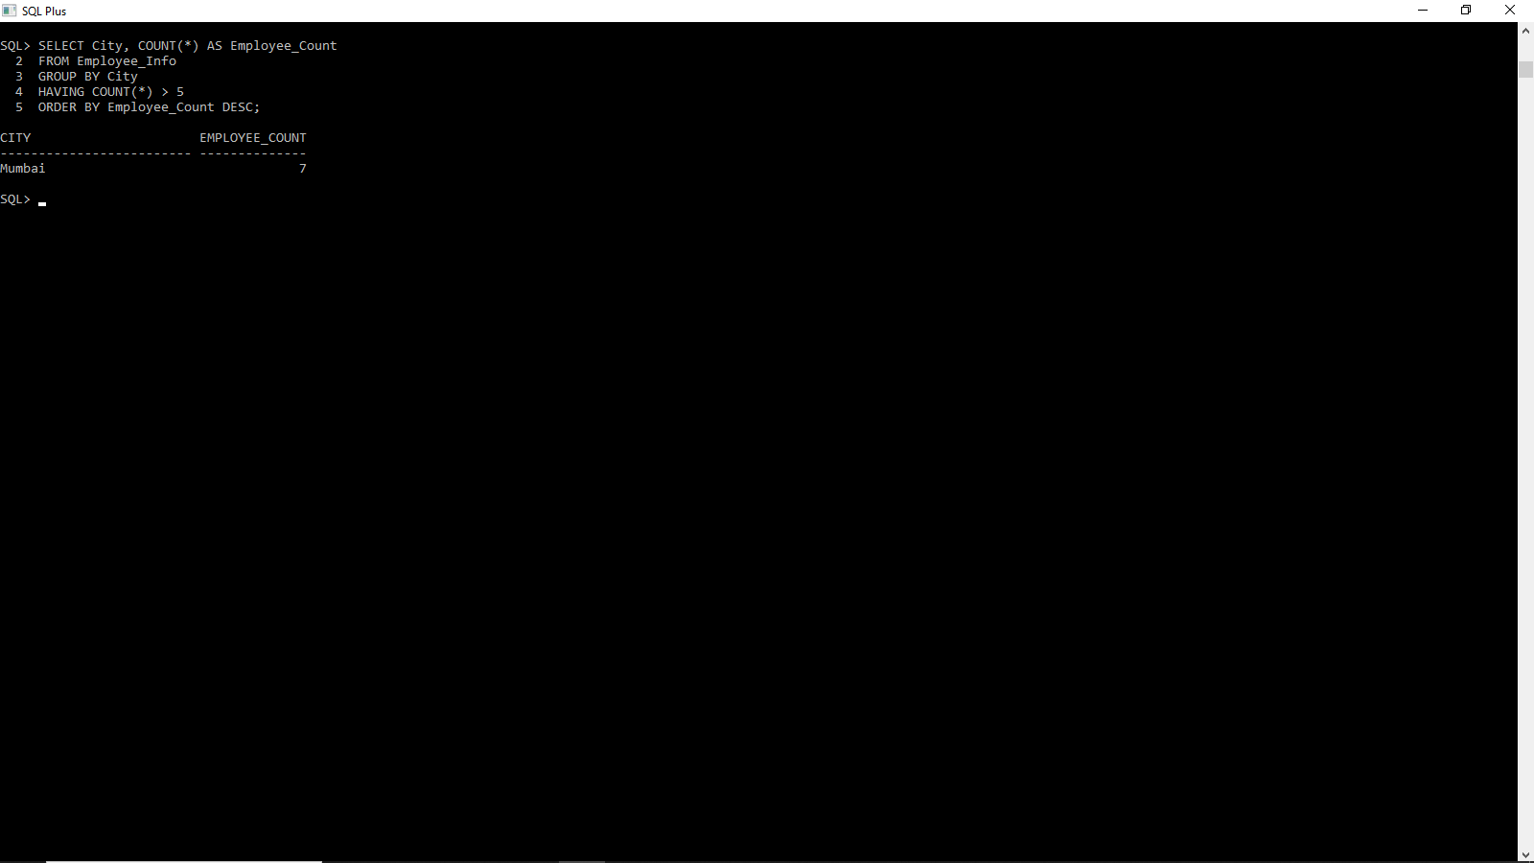

The SELECT statement is used to retrieve data from a table.It allows selecting specific columns or all columns from a table.
Additional clauses like WHERE, ORDER BY, DISTINCT, GROUP BY can be used for filtering and sorting results.

SELECT INTO STATEMENTS

KIRUTHIGAA.K
513423104010

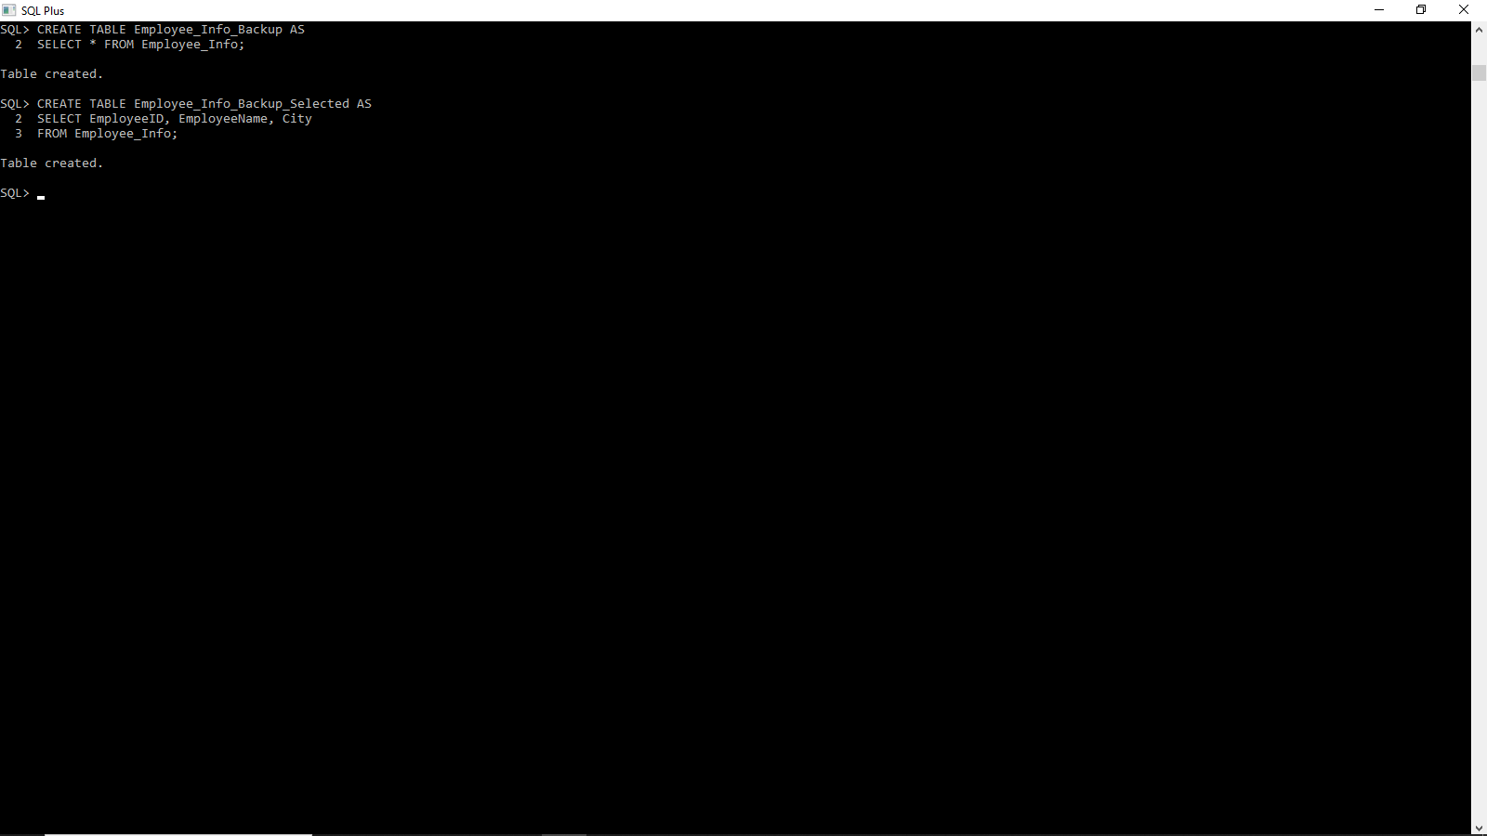

The SELECT INTO statement is used to copy data from one table to another.
It creates a new table and inserts selected records into it. It is useful when you need to make a backup or duplicate data.

OPERATORS IN SQL

KIRUTHIGAA.K
513423104010

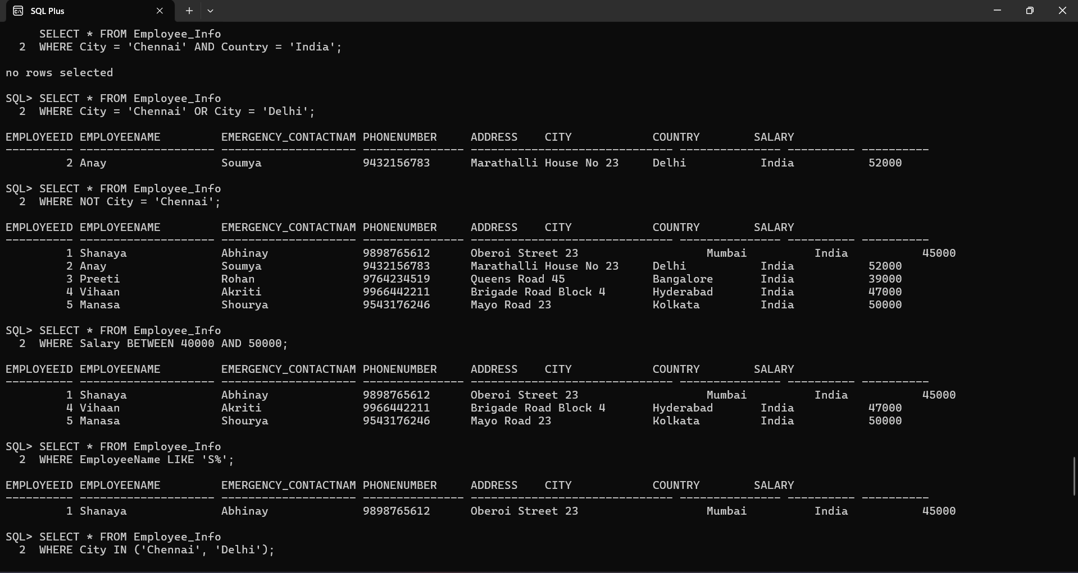

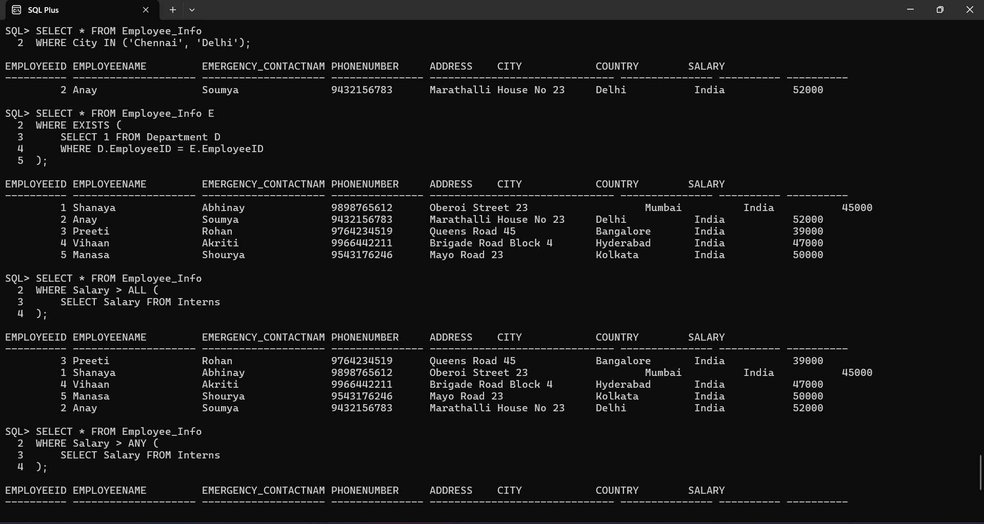

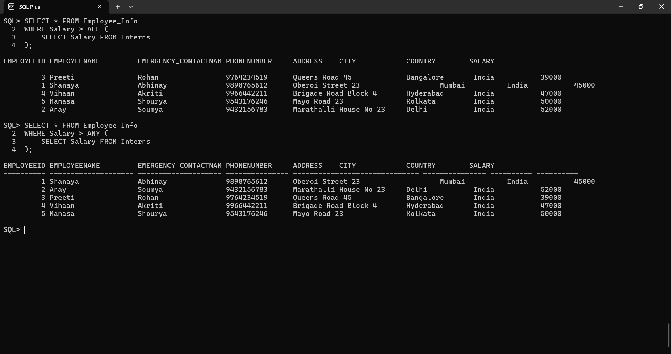

Logical Operators in SQL
Logical operators are used to filter records based on conditions.
Common logical operators are:
- AND: Returns results where both conditions are true.
- OR: Returns results if at least one condition is true.
- NOT: Excludes specific records from the result.
- BETWEEN: Selects values within a given range.
- LIKE: Searches for a pattern in a column.
- IN: Matches values from a list of given values.
- EXISTS: Checks if a subquery returns any records.
- ALL & ANY: Compares a value to a list of values.

LIKE OPERATORS

KIRUTHIGAA.K
513423104010

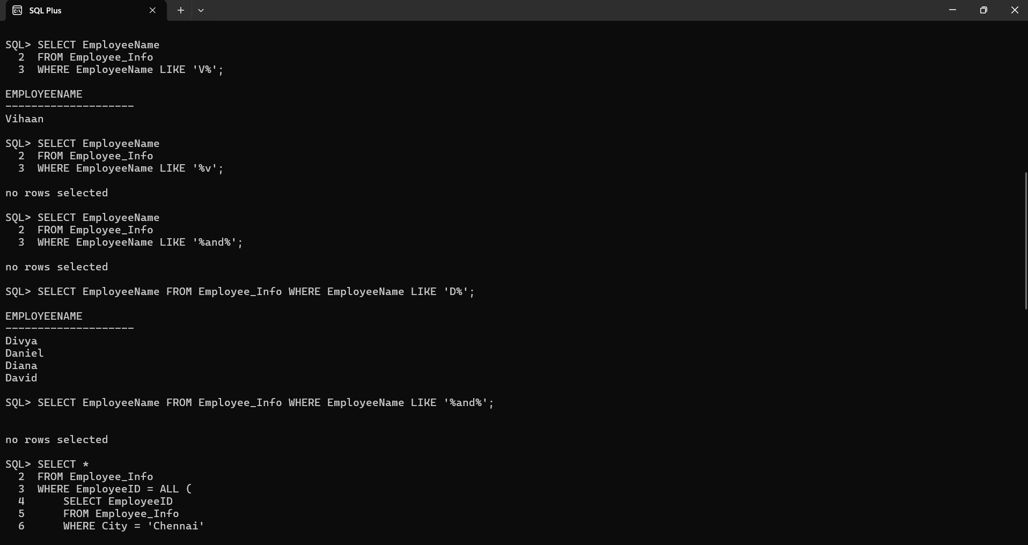

LIKE Operator in SQL
The LIKE operator is used to filter records based on a pattern. It is commonly used in a WHERE clause to find text values that match a specific format.
There are two important wildcards used with LIKE:
→ % (percent sign): Matches zero or more characters.
→_ (underscore): Matches exactly one character.

ALL AND ANY OPERATOR

KIRUTHIGAA.K
513423104010

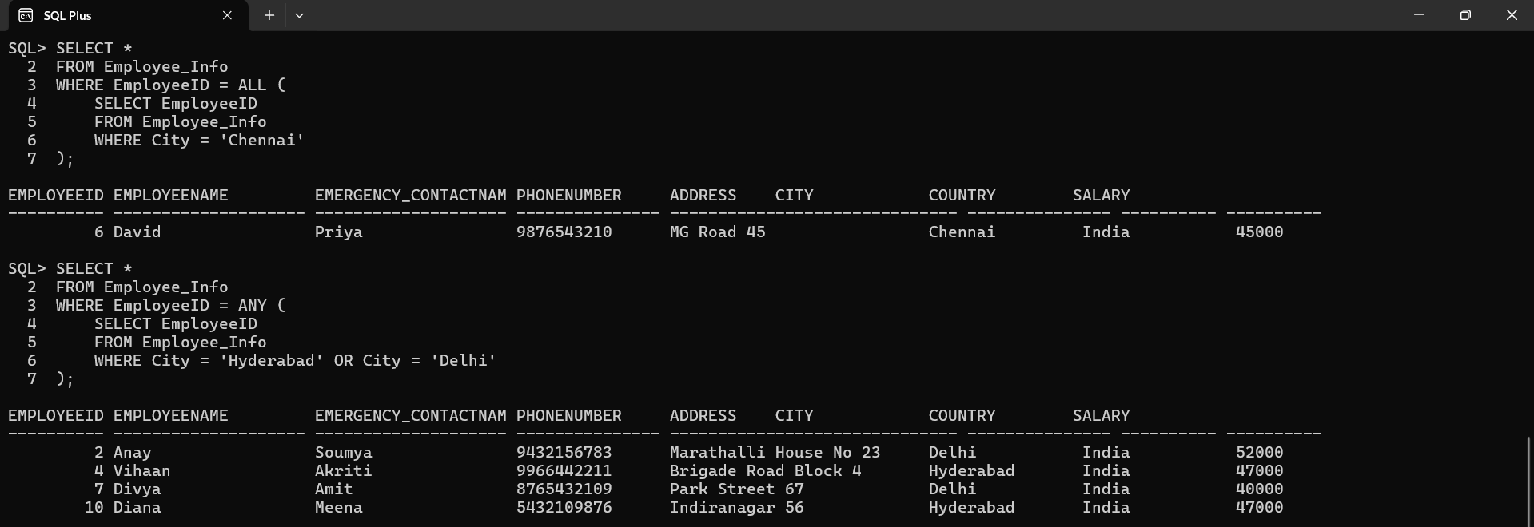

The ALL operator is used to compare a value with all values returned by a subquery. It ensures that the condition is true for every value in the subquery result.It is usually used with comparison operators like =, >, <, >=, <=.

The ANY operator is used to compare a value with any one of the values returned by a subquery. If at least one value matches the condition, the result is included.It is typically used with comparison operators like =, >, <, >=, <=.

AGGREGATE FUNCTIONS

KIRUTHIGAA.K
513423104010

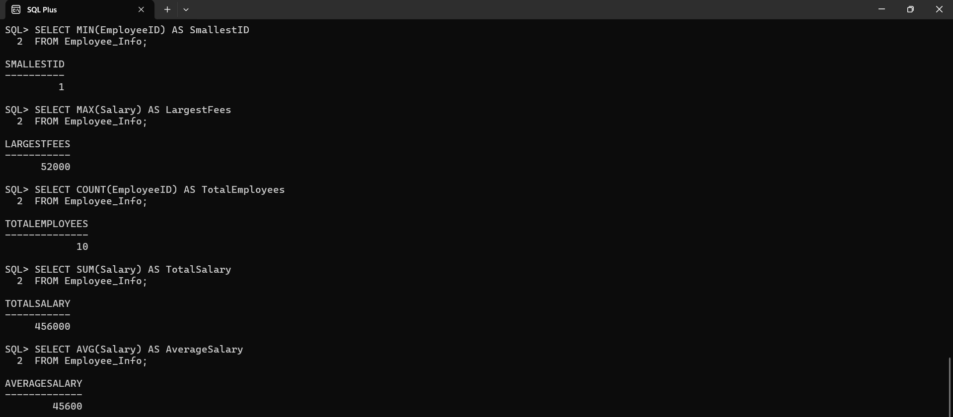

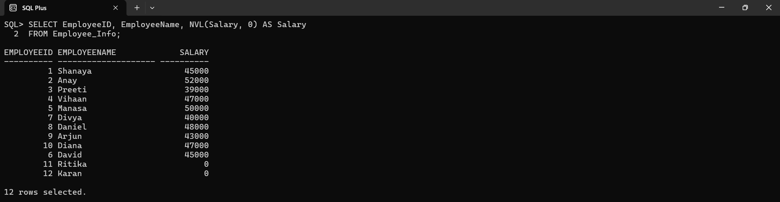

Aggregate functions perform calculations on multiple rows of a column and return a single value.They are commonly used with the SELECT statement to summarize data.
The most commonly used aggregate functions in SQL are:
- MIN() – Returns the smallest value in a column.
- MAX() – Returns the largest value in a column.
- COUNT() – Returns the total number of rows in a column.
- SUM() – Returns the total sum of a numeric column.
- AVG() – Returns the average value of a numeric column.

CASE STATEMENT

KIRUTHIGAA.K
513423104010

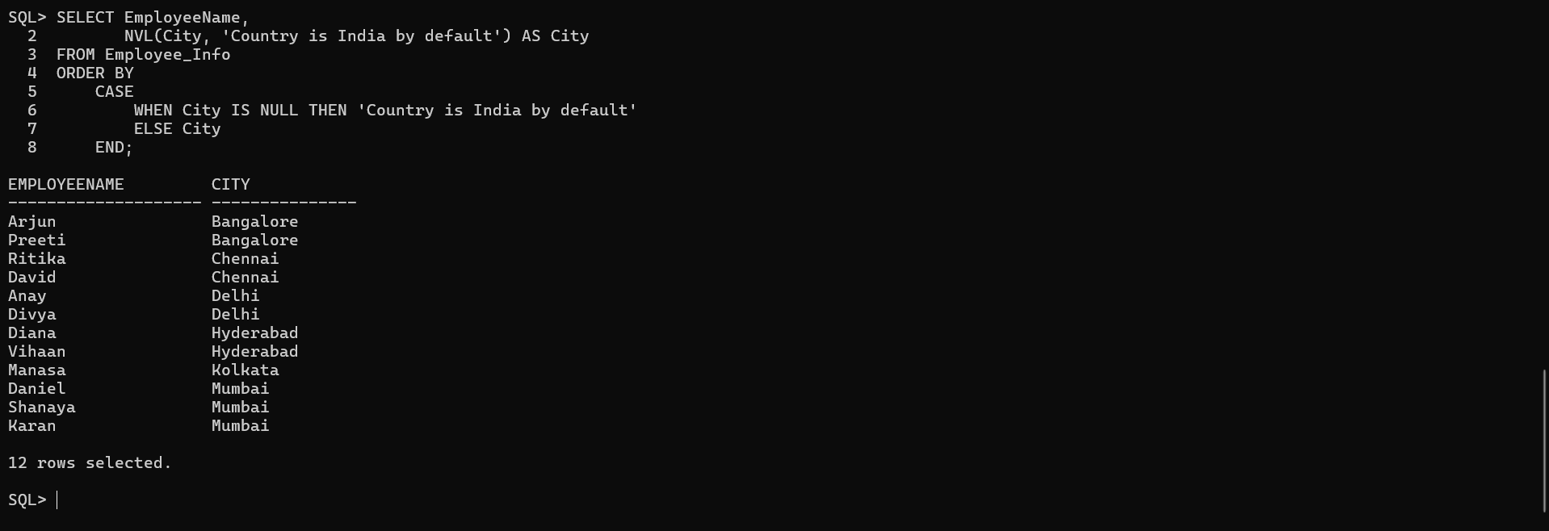

The CASE statement is used for conditional logic in SQL queries. It checks multiple conditions and returns a specific value based on the first condition that is TRUE.
If no conditions match, the ELSE clause is used to return a default value. If there is no ELSE and no condition is met, it returns NULL.

NESTED QUERIES

KIRUTHIGAA.K
513423104010

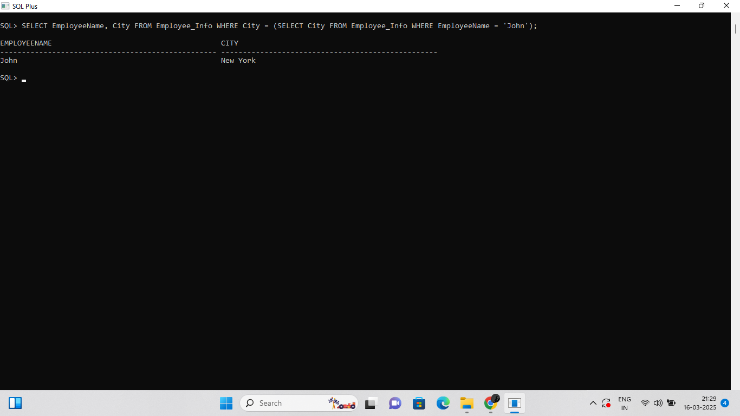

A Nested Query (or Subquery) is a query inside another query.The inner query executes first, and its result is used by the outer query.
Subqueries are used in SELECT, INSERT, UPDATE, DELETE statements to retrieve specific data.

JOINS

KIRUTHIGAA.K
513423104010

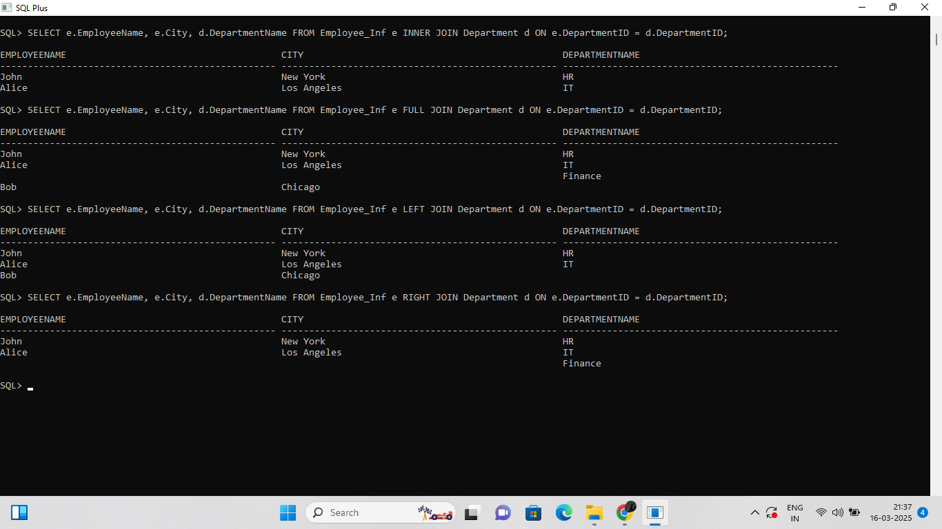

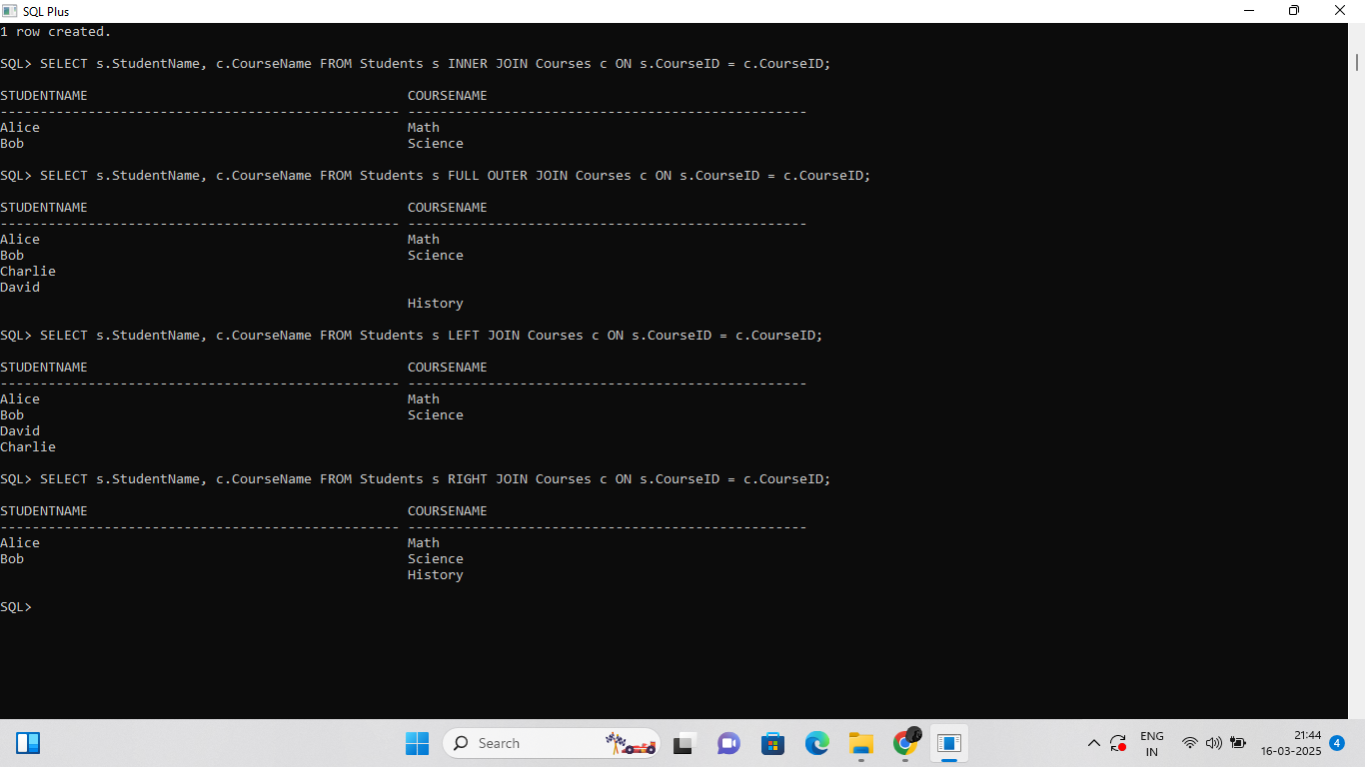

JOINS are used to combine rows from two or more tables based on a common column.They allow retrieving data from multiple tables in a single query.This is useful when information is spread across multiple related tables.

SET OPERATIONS

KIRUTHIGAA.K
513423104010

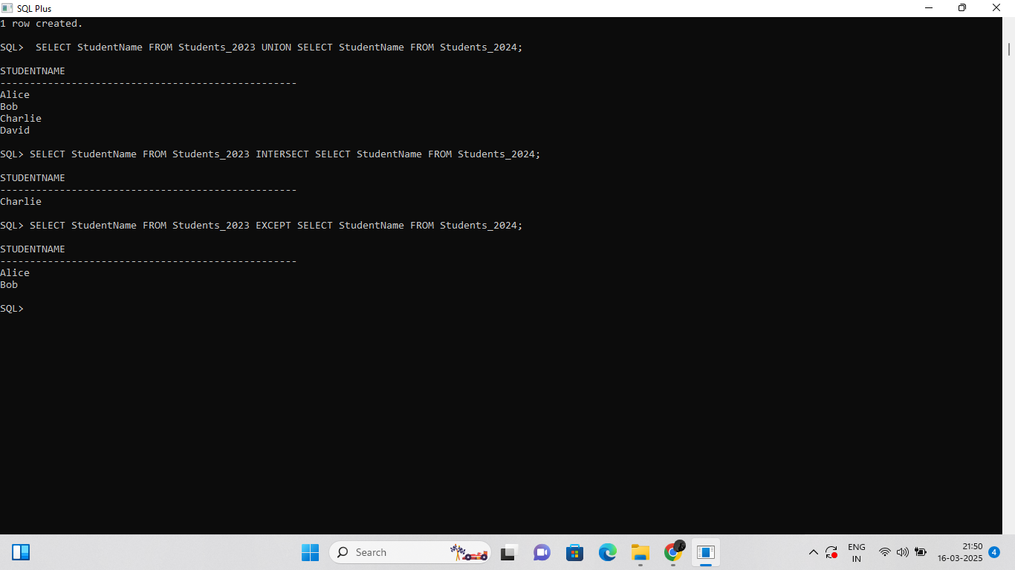

Set operations allow combining results from two or more queries.They work on SELECT statements that return the same number of columns with matching data types.
Common set operations in SQL are:
- UNION – Combines results and removes duplicates.
- UNION ALL – Combines results without removing duplicates.
- INTERSECT – Returns only common records in both queries.
- EXCEPT – Returns records from the first query that are not in the second query.

VIEWS

KIRUTHIGAA.K
513423104010

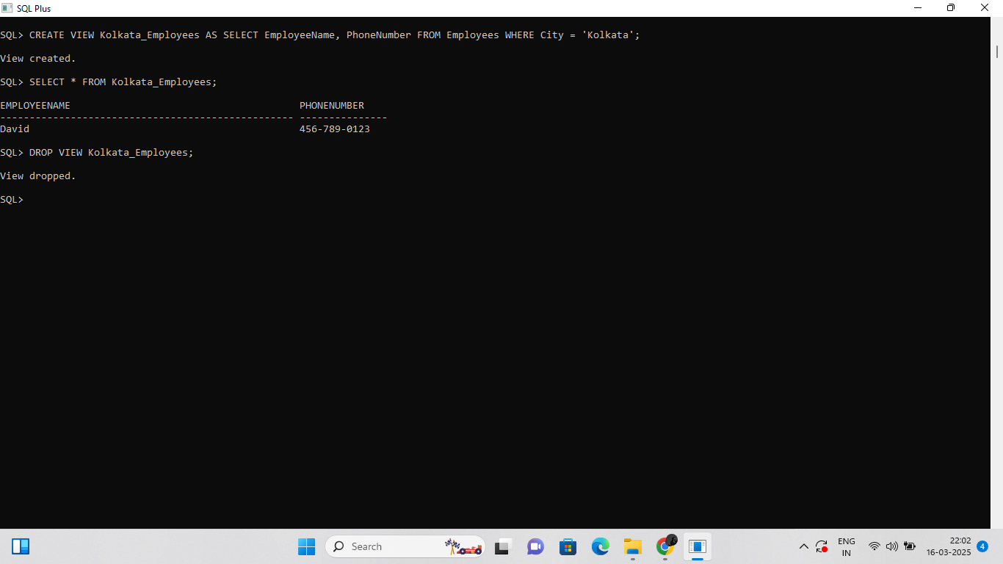

A VIEW is a virtual table based on the result of an SQL query. It contains rows and columns just like a real table but does not store data itself.
A VIEW is created using a SELECT statement that pulls data from one or more tables.

STORED PROCEDURES

KIRUTHIGAA.K
513423104010

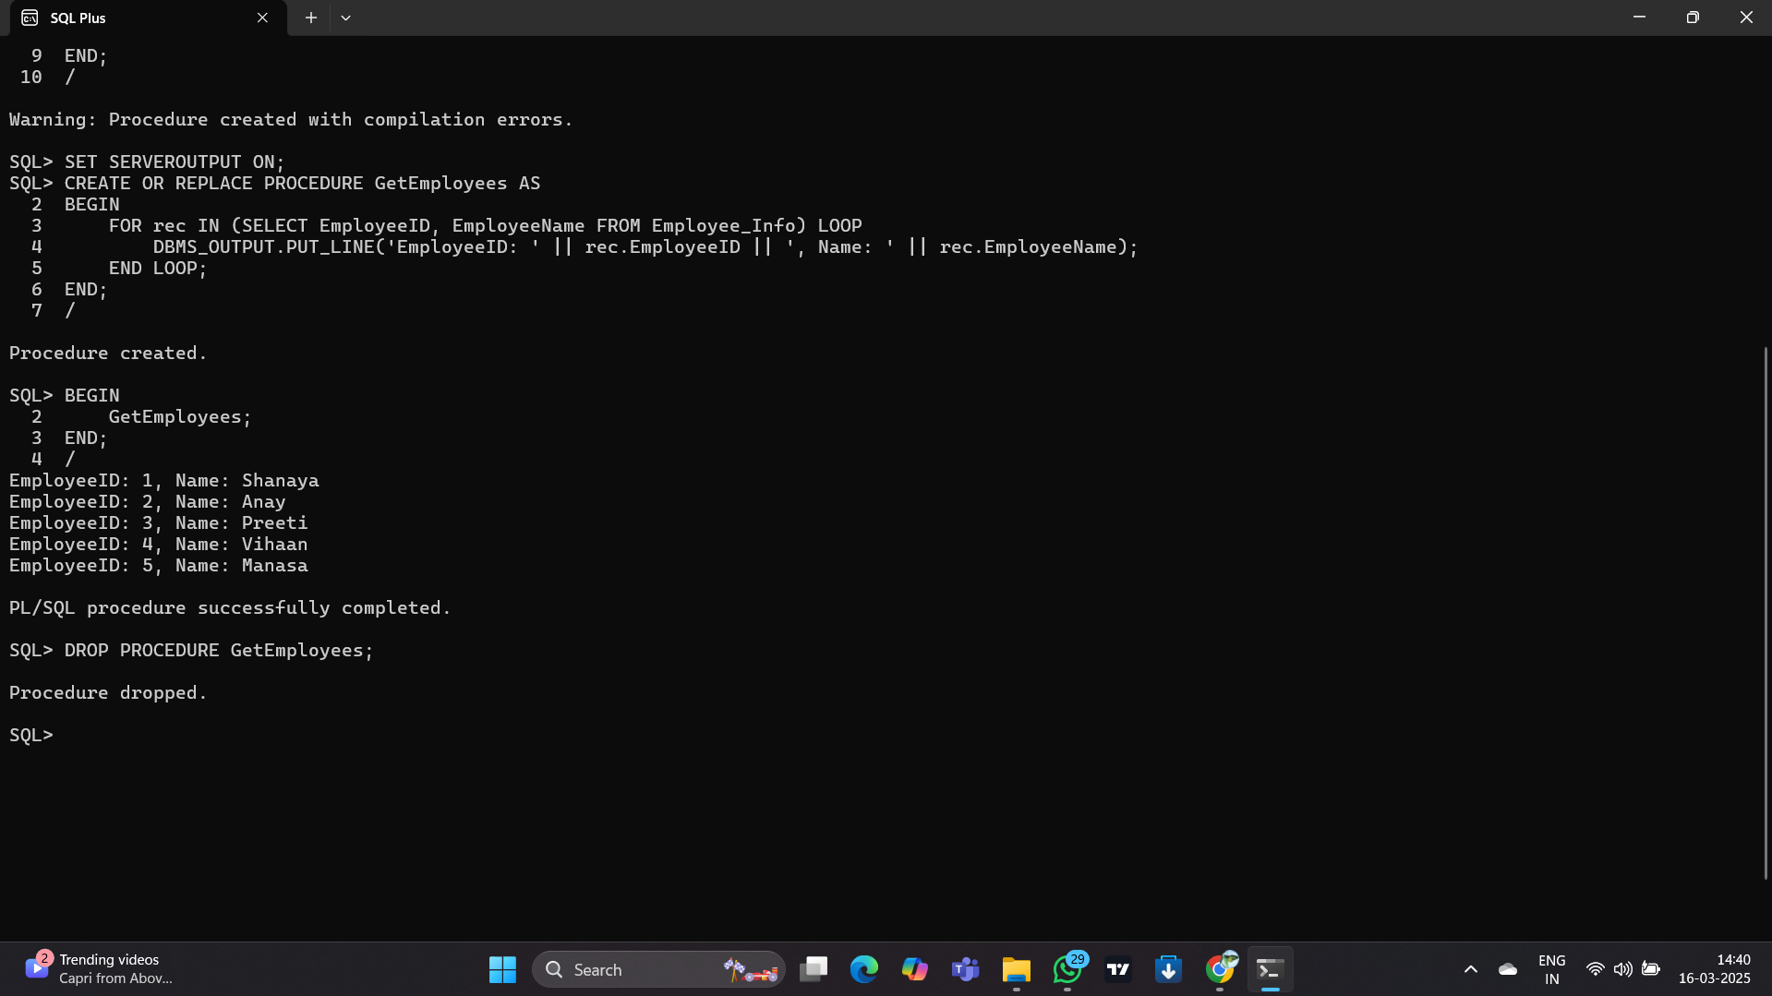

A Stored Procedure is a set of predefined SQL statements stored in a database. It can be executed whenever needed, avoiding repetitive SQL query writing.Stored Procedures improve performance, security, and reusability of queries.

